Information memorandum
version 11.11.2020 English version

Rules for the processing of personal data at D3S a.s.

On 25 May 2018, Regulation No 2016/679 of the European Parliament and of the Council (EU) on the protection of individuals with regard to the processing of personal data, on the free movement of such data and on the repeal of Directive 95/46/EC (General Data Protection Regulation) entered into force. This information memorandum contains information related to the processing of personal data within D3S a.s.

Definitions

Personal data | Means any information relating to an identified or identifiable natural person (‘data subject’); an identifiable natural person is one who can be identified, directly or indirectly, in particular by reference to an identifier such as a name, an identification number, location data, an online identifier or to one or more factors specific to the physical, physiological, genetic, mental, economic, cultural or social identity of that natural person.
Sensitive data | Personal data testifying to national, racial or ethnic origin, political attitudes, trade union membership, religion and philosophical beliefs, criminal convictions, the state of health and sex life of the data subject and the genetic data of the data subject; sensitive data is also biometric data, which allows direct identification or authentication of the data subject.
Data subject | Natural person to whom personal data relate (e.g.: lead, client, customer)
Controller | Means the natural or legal person, public authority, agency or other body which, alone or jointly with others, determines the purposes and means of the processing of personal data; where the purposes and means of such processing are determined by Union or Member State law, the controller or the specific criteria for its nomination may be provided for by Union or Member State law.
Processor | Means a natural or legal person, public authority, agency or other body which processes personal data on behalf of the controller
Processing of personal data | Means any operation or set of operations which is performed on personal data or on sets of personal data, whether or not by automated means, such as collection, recording, organization, structuring, storage, adaptation or alteration, retrieval, consultation, use, disclosure by transmission, dissemination or otherwise making available, alignment or combination, restriction, erasure or destruction.
Consent of the data subject | Means any freely given, specific, informed and unambiguous indication of the data subject's wishes by which he or she, by a statement or by a clear affirmative action, signifies agreement to the processing of personal data relating to him or her.
GDPR | Regulation of the European Parliament and of the Council (EU) 2016/679 of 27 April 2016 on the protection of individuals regarding the processing of personal data and on the free movement of such data and on the repeal of Directive 95/46/EC. It presents an updated legal framework for the protection of personal data in the European area, which sets out rules for the processing of personal data, including the rights of the data subject, from 25 May 2018. In the Czech legal environment, the general regulation will thus replace Act No. 101/2000 Coll., on the protection of personal data rights in the processing of personal data.

Who manages the personal data of the data subject or who is their controller?

D3S a.s. is the controller of your personal data., IČO: 04726421, established at Na Bulánce 619, 257 22 Čerčany registered with the Municipal Court in Prague, Section B, insert 21292 (hereinafter referred to as "Company" or "Controller").

Who is the privacy contact and what is their contact information?

The contact person for the protection of personal data is the person appointed by the controller or processor of personal data on the basis of his professional qualities, who performs statutory tasks, in particular acting as a point of contact for the entity, in all matters related to the processing of personal data and the exercise of the rights of the data subject within the meaning of the law.

Within the Company, the contact person for the processing and protection of personal data is:

Aneta Blažejová
D3S a.s., Na Bulánce 619, 257 22 Čerčanye-mail:
gdpr@d3s-group.com.cz
tel: +420 241 771 214

What are the purposes of the processing of personal data and the legal basis for their processing (reason for processing)?

The purposes of processing the data subject's personal data are:

Contact details of customers for communication in the context of the performance of the contract providing SW
Data on candidates for cooperation and the future of Key Account Managers (referred as KAM)

- Provision of intermediation and advisory services, including all activities compatible with this purpose.
- Simplification and digitisation of communication between the data subject and D3S.
- Disclosure of personal data in the client portal to D3S data subjects and advisors.

Processing means the collection, storage, control, lookups, consultation, use, erasure of data in order to provide the data subject with the maximum quality of service.

We do not want to bother our clients with unnecessary and inappropriate communication. We use the personal data we process primarily to fulfil legal obligations and obligations arising from contracts concluded with data subjects or with other processors or controllers of personal data with whom we exchange personal data for the purpose of securing the required services or on the express consent of the data subject.

What personal data do we process?

We process personal data that is necessary for the above purposes of processing. These are the identification and contact details of the customer (title, name, surname, address, telephone, email) and assignment to a specific service employee of the Company.

What sources does this information come from?

The personal data processed come from data subjects, in particular from contracts relating to services provided to data subjects.

The data subject is always informed about the processing processes specified in this Information Memorandum before the actual processing of personal data.

Who can process the data of the data subject?

The legal regulation of the protection of personal data gives their controller the possibility to entrust the processing of personal data to other processors. The processor of personal data is any natural or legal person who, based on a legal regulation or mandate from the controller, processes personal data. For the processing of personal data of data subjects, the Company uses only verified processors who meet the standards of personal data protection at least at the same level as in the Company. Processors shall comply with the conditions laid down by law for the performance of the processor's activities.

The processors used by the Company to process the personal data of data subjects are as follows:

- Employees or contractors performing a contractually agreed service for the data subject for the primary or secondary compatible purposes of the processing of personal data
- Business partners with whom the Company has a commercial agency contract, cooperation agreement or processing contract
- Providers/operators of information technology used by the Company to fulfil the primary or secondary compatible purposes of the processing of personal data

How long will your personal data be stored?

Personal data obtained by the Company is stored for the entire duration of the contractual relationship and for the next 3 years (pursuant to Act No. 89/2012 Coll. Civil Code) after its termination or for a longer period, if required by a special law.

After the expiry of the period for the protection, personal data are deleted or anonymized or processed only to the extent and for the purposes for which the Company is obliged by the relevant legislation.

Rights of the data subject, possibilities of their application

Rules on the submission of an application and the exercise of the data subject's right

Any data subject may exercise the right of the data subject at any time through an application.

The data subject may apply in one of the following ways or contact the responsible person see section 2.

Personally | D3S a.s., Na Bulánce 619, 257 22 Čerčany
Post | D3S a.s., Na Bulánce 619, 257 22 Čerčany
Email | gdpr@d3s-group.com

If the data subject applies in electronic form and does not request a response in another form, the Company provides the information in commonly used electronic form.

If the Company does not take the measures requested by the data subject, it shall inform the data subject without a request, no later than one month:

- the reasons for non-application,
- the possibility of lodge a complaint with the supervisory authority and to apply for judicial protection.

The information is provided free of charge, except for unjustified and disproportionate (especially repeated) requests where the Company:

- may refuse to comply with the request,
- may require a reasonable fee considering the administrative costs associated with the provision of information,
- evidence of the unjustified or inadequacy of the application.

If the Company has doubts about the identity of the person making the request, it may request the provision of additional information necessary to confirm the identity of the data subject.

The process of applying for rights by the data subject

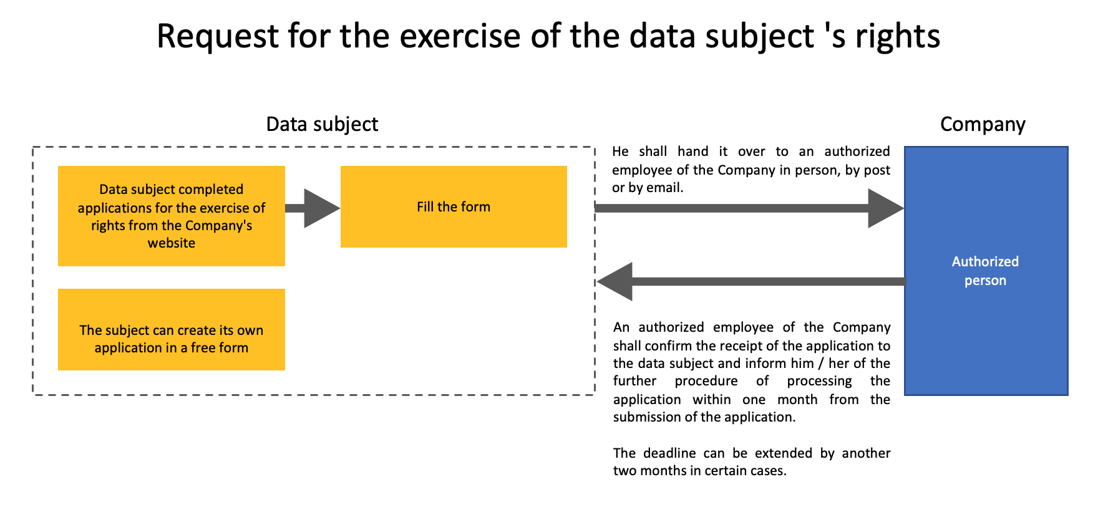

Overview of data subject rights

The processing of personal data does not result in automated decision-making and profiling in the processing of personal data by the Company as a controller.

Right of access by the data subject
The data subject may request access to personal data concerning or processed by the Company. The company shall provide the data subject with a copy of the processed personal data no later than one month after receipt of the request. In view of the complexity or number of cases, the time limit may be extended by a further two months, of which the data subject is informed, including the reason for the extension. For the second and next copy, the Company is entitled to charge a reasonable fee based on administrative costs.

The information shall be transmitted to the data subject in such a way as not to affect the rights of the freedoms of other data subjects.

Right to rectification
The data subject may request the Company to rectify inaccurate or incomplete personal data concerning him or her. The Company accepts requests from the data subject to correct inaccurate data, corrects inaccurate or incomplete personal data without undue delay. At the same time, it shall notify individual data recipients of any corrections to personal data, except in the case of:
- when it proves impossible,
- where it requires unmeasured efforts.

In the event of a request from the data subject, the Company informs the data subject of which recipients it has sent a notice of correction of personal data. It is the responsibility of the data subject to inform the Company of changes in personal data requiring correction.

Right to erasure (‘right to be forgotten’)
The data subject may request the Company to delete its personal data if any of the following situations occur:
- personal data are no longer needed for the purposes for which they were collected or otherwise processed;
- the consent based on which the personal data were processed has been revoked and there is no other legal reason for their processing;
- the data subject has objected to be the subject of a decision based on automated processing of personal data and there are no overriding legitimate grounds for such processing, or an objection has been raised against the processing of personal data for direct marketing purposes;
- the personal data of the data subject have been processed unlawfully;
- the personal data of the data subject must be deleted on the date of fulfilment of the legal obligation laid down in Union or Member State law applicable to the controller;
- the personal data of the data subject have been collected in connection with the offer of information society services to the child.

Exceptions where the right to erasure of personal data does not apply:
- processing is necessary for the exercise of the right to freedom of expression and information,
- processing is necessary to fulfil a legal obligation (required by EU or Czech law),
- processing is necessary for the performance of tasks in the public interest
- processing is necessary for the performance of tasks in the exercise of public authority,
- processing is necessary for the determination, exercise and defence of legal claims,
- processing is necessary in the public interest in the field of public health for:
  - preventive and occupational medicine,
  - assessment of the employee's ability to work,
  - medical diagnostics, and based on EU or Czech law or under a contract with a healthcare professional,
  - the provision of healthcare,
  - the provision of social care,
  - management of healthcare systems and services,
  - management of social care systems and services,

- processing is necessary based on EU or Czech law and for reasons of public interest in the field of public health:
  - protection against serious cross-border health threats,
  - quality and safety standards of healthcare, in ensuring quality and safety standards for medicinal products
  - ensuring standards of quality and safety of medical devices,
  - the data may also be processed by a worker who is subject to an obligation of confidentiality on the basis of professional secrecy under EU or Czech law, under his own responsibility under EU or Czech law, on the basis of rules established by national authorities, on the basis of rules laid down by another person,
  - another person who is subject to an obligation of confidentiality under EU or Czech law under rules laid down by the competent national authorities,

- processing is necessary for scientific and historical research purposes, for statistical purposes, provided that:
  - it is not possible for purposes to be met by processing that does not allow the data subjects to be identified,
  - the erasure of personal data is likely to prevent or seriously jeopardise the fulfilment of the objectives of that processing,
  - technical and organisational measures are in place to ensure appropriate safeguards for the rights of data subjects, to ensure the minimisation of the data processed.

The Company accepts requests for deletion of personal data from the data subject, deletes personal data, if the processing is not subject to an exception. If the data have been disclosed, the Company (considering the available technology and costs) takes reasonable steps to inform other personal data controllers who are also processing the data that the data subject is asking them to delete:
- all copies,
- Replication
- references to this information,
- the controllers who process the personal data have been informed that the data subject is requesting the deletion of the data (links, copies, replication).
The controller shall notify the recipients of the data of the erasure of personal data, except in the case of:
- when it proves impossible,
- where unmeasured efforts so require,
- in the case of a request from data subjects, the controller shall inform the data subject of which recipients he has sent a notification of the erasure of personal data.

Right to restriction of processing
The data subject may ask the Company to restrict the processing of its personal data if any of the following situations occur:
- the data subject has denied the accuracy of the personal data for the period necessary for the Company to be able to verify the accuracy of the personal data;
- the processing of personal data is unlawful, but the data subject refuses to delete the data and instead requests a restriction on their use;
- The company no longer needs personal data for processing purposes, but the data subject requests it for the determination, exercise or defence of legal claims;
- The data subject objected to the processing of personal data pursuant to Article 21(1) of the Basic Regulation. 1 GDPR regulation until it is verified whether the legitimate reasons of the Company outweigh the legitimate reasons of the data subject.

If the processing of data has been restricted, personal data may be processed only with the consent of the data subject, except for the storage of personal data.

If the data subject requests a restriction on the processing of personal data, his data may be processed without his consent only for the reasons of:
- the determination, exercise and defence of legal claims,
- protection of the rights of another natural or legal person,
- public interest of the EU or its Member State.

The Company shall notify individual recipients of personal data of restrictions on the processing of personal data, except in the case of:
- when it proves impossible,
- where unmeasured efforts so require,
- in the case of a request from the data subject, the Company informs the data subject of which recipients it has sent a notice of restriction of the processing of personal data; The company must verify the accuracy of the personal data in the event that it is denied by the entity; if the processing restriction is lifted, the data subject (who has reached the limit) must be notified.

Right to data portability
The data subject has the right to obtain personal data concerning him/her and provided to the Company in a structured, commonly used and machine-readable format, provided that this right must not adversely affect the rights and freedoms of other data subjects.
Exceptions where the right to portability of personal data does not apply:
- the processing entrusted to the controller and which are necessary for the performance of tasks in the public interest,
- processing by which the controller is entrusted, and which are necessary in the exercise of public authority,
- processing of special categories of personal data, where the right to portability of personal data does not apply, because EU or Czech law stipulses that the explicit consent of data subjects cannot be exercised.

The exercise of the right shall be without prejudice to the right to erasure of data.

Right to object
The data subject may object at any time to the processing of personal data concerning him or her. Furthermore, the Company does not process personal data unless it proves a serious legitimate reason for processing that outweighs the interests or rights and freedoms of the data subject, or for the determination, exercise or defence of legal claims.

Automated individual decision-making, including profiling
The data subject shall have the right not to be subject to a decision based solely on automated processing,
including profiling, which produces legal effects concerning him or her or similarly significantly affects him or her.

Right of withdrawal of consent
The data subject has the right to withdraw consent to the processing of personal data for the purpose for which he has given his consent at any time; withdrawal of consent is without prejudice to the processing of personal data before its withdrawal.

The data subject may exercise this right by submitting the completed Form Revoking consent to the processing of personal data and submitting it in one of the following ways or contacting the contact person see section 2.

Personally | D3S a.s., Na Bulánce 619, 257 22 Čerčany
Post | D3S a.s., Na Bulánce 619, 257 22 Čerčany
Email | gdpr@d3s-group.com

Withdrawal process Consent to the processing of personal data

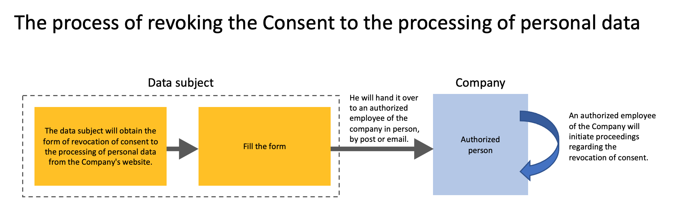

The authorized employee of the Company is the contact person for the processing and protection of personal data see section 2.

Right to lodge a complaint
The data subject has the right to lodge a complaint with the Company, at D3S a.s., On Bulánec 619, 257 22 Cerčany or at the supervisory authority, which is the Office for Personal Data Protection, Pplk. Sochora 27, 170 00 Prague 7, www.uoou.cz.

When can you exercise your rights and what?

The data subject may exercise his rights at any time in the form of a request addressed to the Company. The following table provides an overview of the applicable rights depending on the legal basis according to which the Company processes personal data.

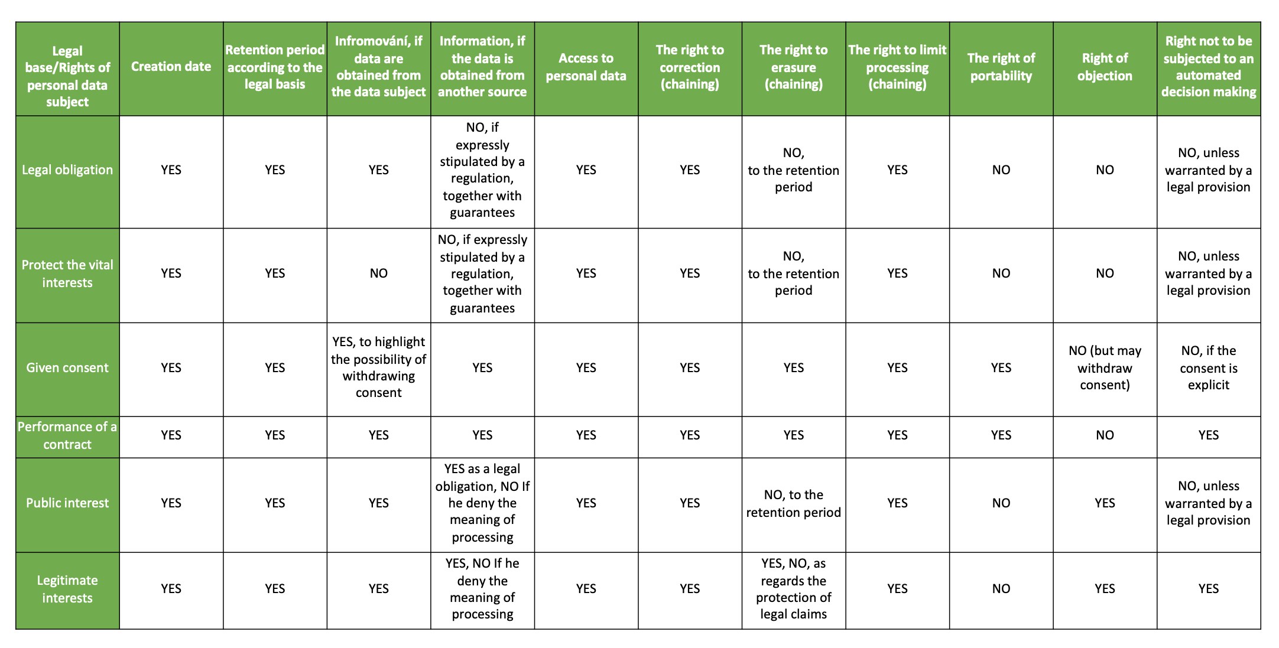

Report a privacy breach

Company D3S a.s. it has an internal process for reporting data breaches to data subjects, duly respects the fulfilment of the reporting and reporting obligations of the Office for Personal Data Protection (OC) and in cases of such breach is ready to cooperate with all interested parties.

Final provisions

This Information Memorandum is effective and valid from 25.5.2018. The current version is published on the Company's website or at the registered office of the Company and its branches.

